# XENDIT API KEY GENERATION

## API Key Permissions

Each API key has permission of a product that you can configure. There are three types of API key permission

* None: No product access granted, meaning you forbid your API key to perform any action.
* Read: Granting the ability to read-only access or fetch data using API of a specific product. You'll grant Read access if you only need to, for example, get your account balance or get payment detail.
* Write: Granting the ability to read and write data using API. You'll grant Write access if you want to read or perform action ie create Invoice, create Disbursement, get VA, etc

## Generate API Keys

Generate API key can easily be done with the following steps:

1. Visit API Key page
2. Click Generate secret key
3. Select the API key permission
4. Enter your user password to authenticate yourself
5. Save the API key securely and apply the new API key to your system

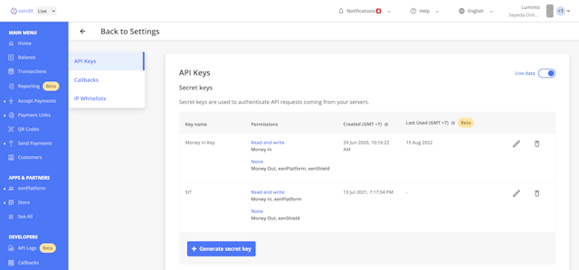

# PAYPAY API CREDENTIALS

## How do I create REST API credentials?

REST API credentials include a client ID and secret. Here's how you generate the credentials:

1. Log in to the PayPal Developer Portal using the same credentials you use for PayPal.
2. On the Apps & Credentials page, click Live or Sandbox depending on whether you need an app for testing (Sandbox) or going live (Live).
3. Click Create App under REST API apps. Any previously created REST API apps will appear in the table above the Create App button.
4. Enter the name of your REST API app in the App Name field, and select a Sandbox business account to associate with your app.

Note: Remember that you can't use a Live credit card in Sandbox, and you can't use a test credit card in your Live account.

1. Click Create App.

Your credentials, the client ID and secret, are displayed on the app details page that displays after you click Create App.

1. Request permissions for REST API features that apply to your integration, such as:

* Invoicing API
* PayPal Here
* Subscriptions
* PayPal payments
* Connect with PayPal
* Customer Disputes API
* Payouts

1. When you are ready to take your code live, make sure you create a Live app to get live credentials.

Use the Live and Sandbox toggle at the top of Apps & Credentials to switch between app types and view your credentials for each.

Notes:

* You should be able to complete transactions in the Live environment right away.
* Both environments use the same URL. Only the REST API credentials (Client ID and Secret) tell you which environment you're in.
* Don't share your Live REST API credentials with anyone.